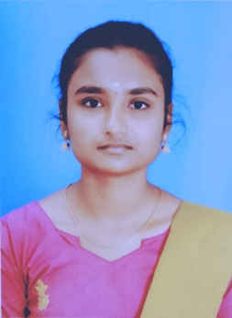Kavya.M

2/105, Thokkupatti Pudhur &(PO), Aravakuruchi (TK), Karur-639202

6381030031|[kavyamrgsn@gmail.com](mailto:kavyamrgsn@gmail.com)

Carrier Objective:

Looking for a challenging position in organization where my subject knowledge, logical and analytical skill greatly enhance the organization success and my growth.

Educational Qualification:

|  |  |  |
| --- | --- | --- |
| Course Name | Institution | Percentage |
| H.S.C | Govt Girls HR SEC School Chinnadharapuram. | 84% |
| S.S.L.C | Govt Girls HR SEC School Chinnadharapuram | 90% |
| BSc (CS) | Annai Women’s College, Karur | 83% |

Skills

* Fluent speaking skill
* Known programming c, c++, Java

Interpersonal Skills

* Hard working and smart working
* Team works and self confidence
* Positive attitude and adopted with any situation

Hobbies & Interest

* Dancing
* Listening to music

Achievements

* Attended “International Conferences” titled “IOT AND BLOCKCHAIN TECHNOLOGY” and “MACHINE LEARNING” and 4 “STATE LEVEL CONFERENCES”
* I am participated and achieved dance certificates in college level competition and inter collegiate dance competitions.

Personal Details

Name : M. Kavya

Father’s Name : A. Murugesan

D.O.B : 04/11/2003

Marital status : Single

Nationality : Indian

Gender : Female

Language known: Tamil, English, Hindi

Declaration

I hereby declare that all the information provided above is accurate to the best of my knowledge.

PlACE: SIGNATURE

DATE: